

**Writing the path back to target**

Speech given by

Mark Carney, Governor, Bank of England

At the University of Sheffield Advanced Manufacturing Research Centre, Sheffield 12 March 2015

It is a great pleasure to be in the City of Steel to honour both its historic role in forging the industrial foundations of modern Britain and its current leadership in promoting advanced manufacturing for the post-industrial age.

This city has been at the very forefront of innovation for hundreds of years. In the 18th Century Sheffield revolutionalised steelmaking with the discovery of the crucible steel process. By the mid-19th Century the city represented almost half of Europe’s total steel output. Since then, Sheffield has remained fleet of foot through hard work and innovation.

The University of Sheffield’s Advanced Manufacturing Research Centre is a prime example of that spirit. No one knows better than you that manufacturing needs to become ever-more productive to prosper in a world of steadily falling prices and relentless international competition.

Prices for advanced manufactured goods fell on average by around 1 per cent a year during the decade prior to the crisis. They also have dropped steadily relative to those of simpler manufactured products – by

30 per cent over the last two decades – reflecting superior productivity growth.1 Your customers and society as a whole are the beneficiaries of your doing much more with less. The strong recovery of UK manufacturing over the past year – with growth stronger than at any point in the decade prior to the crisis – is a testament to the sector’s focus on continual improvement.

Manufacturing punches well above its weight in spending on research and development. Manufactured products R&D has grown by a quarter since the mid-1980s and currently accounts for well over two-thirds of total UK spending on innovation. Advanced manufacturing sectors, including pharmaceutical, aerospace and automotive, represents well over half of this amount.

Such contributions are crucial for the UK’s prosperity because our long-run economic performance hinges on productivity growth. Productivity is the ultimate determinant of people’s incomes, and with it the capacity of our economy to support health, wealth and happiness.

The best contribution the Bank of England can make to these goals is to maintain monetary and financial stability.

Our remit for monetary stability is simple: achieve 2% CPI inflation by setting Bank Rate, the fulcrum around which all other interest rates in the economy pivot, and, as necessary, conducting large-scale asset purchases to affect overall financial conditions. Our monetary policy framework is known as Inflation Targeting.

1 Based on ONS producer price indices. More advanced includes: printing and recording, chemicals, pharmaceuticals, computing, electrical, machinery, motors and equipment. Less advanced includes: textiles, products of wood, paper, rubber, basic metals, non-metals, other materials and other manufactured goods

Over the past two decades, Inflation Targeting central banks have established good track records of keeping inflation from being too high. It has brought tangible benefits to the UK, particularly lowering the volatility of both inflation and of income growth.2

# Chart 1: Inflation has fallen globally(a)

Higher than 5% Between 3% and 5% Between 1% and 3%

Between 0% and 1% Deflation

Proportion of countries

100%

80%

60%

40%

20%

0%

2000 2001 2002 2003 2004 2005 2006 2007 2008 2009 2010 2011 2012 2013 2014 2015

(a) Sample of 80 countries in 2000, growing to 125 at end-2014.

# Chart 2: 16 of 18 inflation targeting economies had inflation below target in January 2015(a)

Number of countries with inflation below target Number (sample of 18)

18

16

14

12

10

8

6

4

2

0

2000 2001 2002 2003 2004 2005 2006 2007 2008 2009 2010 2011 2012 2013 2014 2015

1. The economies are: US, UK, Canada, euro area, Norway, Sweden, Switzerland, Australia, China, India, Indonesia, Malaysia, New Zealand, Philippines, South Korea, Taiwan, Thailand and Brazil.

2 The volatility of inflation fell by around four-fifths in the Inflation Targeting (IT) era compared to the pre-IT era. The volatility of real GDP growth fell by around one-quarter. See also King, M (2007), “The MPC ten years on”.

But now those central banks, including the Bank of England, are being tested by inflation that is too low.

Inflation has fallen globally (**Chart 1**) and is below target in 16 of 18 Inflation-Targeting major economies (**Chart 2**). 11 of those countries have inflation rates below 1%.3

Today I will discuss the consequences for the UK of persistently low global inflation, why it matters, and what the Bank of England can do about it so that businesses and households in Sheffield and beyond can focus on what really matters to them. The bottom line is that there is a risk that the combination of persistently low global inflation and the strength of sterling could weigh on prices here for some time. But despite these headwinds, a solid UK expansion, underpinned by strong domestic demand growth, leaves us on track to return inflation to target within the next two years. To deliver that outcome, a gently rising path for Bank Rate is likely to be required over the next few years.

# On ‘lowflation’ and deflation

Why do we target the low, but positive, inflation rate of 2% rather than a zero or even negative rate?

The simple answer is because it’s our job, given to us by the democratically elected representatives of the British people. We are accountable to Parliament for meeting it. On the occasions when inflation moves by more than 1 percentage point away from the target, we are required to explain publicly why that’s happened and what we’re doing about it in an open letter to the Chancellor. Before this year, that had happened 14 times in the past when inflation has been too high.

The particularly subdued January inflation rate meant I had to write the 15th open letter, the first to address these points with respect to very *low* inflation. It is likely that I will have to write a few more of these over the course of the year.

Our remit for 2% inflation reflects the lessons of the past, including the fight against high inflation in the 1970s and 1980s, as well as the deflationary disasters that have followed past financial crises.

Low, stable and predictable inflation helps to stabilise households’ and firms’ expectations about future price increases. That helps them plan their spending, investment and hiring decisions. In short, the Bank of England worries about inflation so that everyone else doesn’t have to.

High inflation damages growth, in part, because high inflation also tends to be volatile, generating uncertainty that makes important economic decisions more difficult.

In contrast, a little inflation ‘greases the wheels’ of the economy, helping it to absorb shocks.

1. The UK’s CPI inflation rate of 0.3% is accompanied by PCE inflation of 0.2% in the US and HICP inflation of -0.3% in the euro area.

One example of that is in the labour market, where workers usually resist reductions in their cash wages when economic conditions deteriorate. This behaviour can prevent the inflation-adjusted value of wages from declining when demand for labour is weak, leading to unemployment. If that is the case, it may be better for the economy as a whole if firms’ real labour costs can adjust over time through increases in prices

– a little inflation – instead.4

A positive average inflation rate also gives monetary policy space to respond to negative shocks by cutting interest rates.

That’s because in normal times the ‘equilibrium’ level of interest rates at which the economy would tend to settle without generating inflation reflects, broadly, the rate of underlying growth in the economy plus the inflation target. The lower is average inflation, the less scope there would be for monetary policy to reduce interest rates in response to shocks before they approach zero. Because the equilibrium rate is so central to monetary policy I will come back to discuss it further in a few moments.

Persistently low inflation can be difficult. Deflation proper – by which I mean a persistent and generalised decline in prices – is potentially dangerous. During the Great Depression, sharp falls in prices reinforced collapsing output and skyrocketing unemployment.

To consider how susceptible we might be to it, it is helpful to review why such deflationary spirals are potentially dangerous.

A commonly cited reason is that falling prices prompt households and firms to delay spending and investment. The subsequent reduction in demand causes further reductions in prices through higher unemployment. That further reduces incomes and spending, drawing the economy into the vortex.

The relevance of that dynamic depends on households’ willingness and ability to delay consumption.

There are limits to the ability of households to delay consumption of some items, however, like food. And the psychology of instant gratification – the tendency for all of us to discount the future heavily relative to the present – mutes the willingness of households to wait for lower prices. It’s fair to say that thus far there’s no evidence as yet of delayed gratification taking hold in the UK.5, 6

1. See Tobin (1972), “Inflation and unemployment”, American Economic Review, 62. The idea is that if the economy is hit by a shock which requires real wages to fall (like a negative productivity shock), this can happen through either (a) keeping prices fixed (i.e. zero inflation) and cutting money wages, or (b) fixing money wages and increasing the price level (i.e. positive inflation). The first path may involve significant unemployment when money wages are downwardly rigid. The second, by contrast, may deliver the same reduction in the real wages at a unemployment lower cost. See also e.g. Kim, J and F Ruge-Murcia (2009), “How much inflation is necessary to grease the wheels?”, Journal of Monetary Economics, 56.
2. Retail sales grew by 2.3% in the three months to January, the fastest since April 2002. Consumer confidence in the general economic situation is currently over 1 standard deviation above its historical mean and from mid-2014 has been around its highest level since May 1998.
3. More broadly, the evidence for consumption delay is not compelling. Bachmann et al (2015) find for the US that a one percentage point increase in expected inflation during the recent zero lower bound period *reduces* households’ probability of having a positive attitude towards spending by about 0.5 percentage points. Hori and Shimizutani (2005) find some evidence of lower price expectations

There would be, however, a more clear and present danger arising from the balance sheets of households and firms should deflation persist. This is a concern across the advanced world, where private debt levels remain very high relative to history, including the UK (**Chart 3**).

# Chart 3: UK household debt remains high relative to GDP(a)

120%

100%

80%

60%

40%

20%

0%

1949

1951

1953

1955

1957

1959

1961

1963

1965

1967

1969

1971

1973

1975

1977

1979

1981

1983

1985

1987

1989

1991

1993

1995

1997

1999

2001

2003

2005

2007

2009

2011

2013

(a) Total household liabilities relative to GDP.

# Chart 4: The dog that hasn’t barked: core inflation fell much less than expected across the G7 during the Great Recession(a)

Change in unemployment (percentage points)

1970–79

1980–94

‐1 0 1 2 3 4 1995–2006

1

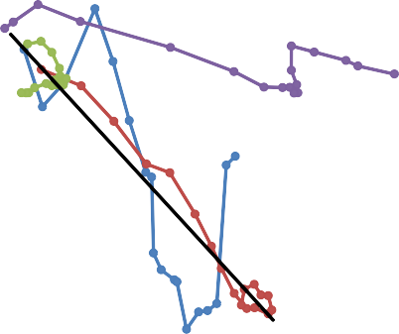

0.5

0

‐0.5

‐1

‐1.5

‐2

‐2.5

‐3

‐3.5

‐4

Great Recession Fitted past recessions

Change in core inflation (percentage points)

(a) Source: IMF World Economic Outlook, April 2013, Chapter 3.

When a household takes out a mortgage or a firm secures a loan, the amount owed is denominated in cash terms – that is, not adjusted for inflation. Unexpected, generalised, and persistently falling prices then mean

being correlated with consumption delay in Japan, but the effects do not look large. Finally, consumption delay is less compelling for households who are financially constrained and whose consumption varies more strongly with current income. Benito and Mumtaz (2009) estimate between 20-40% of UK households display such ‘excess sensitivity’. See Bachmann, R, Berg, T and Sims, E (2015), “Inflation expectations and readiness to spend: cross-sectional evidence”, American Economic Journal: Economic Policy, 7(1); Hori, M and Shimizutani, S (2005), “Price expectations and consumption under deflation: evidence from Japanese household survey data”, International Economics and Economic Policy, 2; Benito, A and Mumtaz, H (2009), “Excess sensitivity, liquidity constraints, and the collateral role of housing”, Macroeconomic Dynamics.

the real value of debt increases: the same amount of money is owed, but that money now buys more goods and services. As a result, more consumption or investment needs to be foregone to service the debt.

This debt-deflation dynamic was at the core of the Great Depression7 and in the Japanese malaise following the collapse of the asset bubbles of the 1980s. It would be a particular concern if the pace of wage growth were to follow prices down. There is no evidence of that in the UK, where wage growth has picked up over the past six months. And more broadly, following the 2008 financial crisis debt deflation has been the dog that hasn’t barked (**Chart 4**).8 But we shouldn’t rest too easy - there are several reasons why the dog might have just been sleeping, and central banks need to be vigilant against the risk that recent low inflation stirs it from its slumber.

# Global factors and domestic inflation

Low global inflation matters for the UK because we are an open economy.

Around one-third of the goods and services consumed by UK households are imported, creating a direct channel from global influences to UK prices.

And the UK’s exports are around 30% of GDP, opening an indirect channel through which global activity affects costs and prices in the UK through demand for our products.

The importance of these channels has waxed and waned over decades, with changes to both the degree of global integration and the conduct of monetary policy.

Under the Bretton Woods system of fixed exchange rates prevailing until the early 1970s relatively closed financial and goods markets may have contributed to lower cross-country co-movements between inflation rates (**Chart 5 (a)** – see annex).

After Bretton Woods collapsed, countries’ inflation rates became more highly correlated across the advanced world as they lacked the strong nominal anchors necessary to manage global cost shocks and subsequent attempts at disinflations (**Chart 5 (b)** – see annex).9

That situation persisted until the early 1990s ushered in the era of Inflation Targeting (**Chart 5 (c)** – see annex). Central banks took greater, though not total, mastery over their monetary destinies. With increased global integration of capital, goods, and labour markets, inflation stabilisation has faced powerful countervailing forces. Perhaps as a result, advanced economy inflation rates have moved more closely together under Inflation Targeting than under Bretton Woods.

1. First identified by Irving Fisher (1933), “The debt-deflation theory of great depressions”, Econometrica. 8 See IMF (2013), World Economic Outlook, Chapter 3, April.
2. In the UK, “the framework for monetary policy was, at best, opaque”, according to King (1997), “The Inflation Target five years on”.

The correlations between inflation rates in major economies grew in the wake of the crisis (**Chart 5 (d)** – see annex). As they have written their monetary scripts, central banks have at the very least had an editor. If they are not careful, they could become ghost writers.

# Why is inflation low globally?

Of course, an important global factor behind current low headline inflation has been the sharp fall in the price of oil, which has been driven primarily by large increases in its actual and potential supply. This means that while it’s been a short-term drag on inflation, it’s good news for growth. The Bank estimates that lower oil prices will boost the level of UK-weighted global GDP by a little under 1 percentage point over the next three years, with a consequent boost in demand for UK exports of around 2 ½ %.

Lower oil prices will also boost UK domestic demand directly as households spend their windfall. Our forecast conservatively assumes that they save 40 pence in every pound of that amount. On balance, there is likely upside risk to growth and inflation from this assumption.

Oil isn’t the only reason why inflation is low globally. Measures of inflation that strip out volatile factors

– so-called ‘core’ inflation – have been trending down as well (**Chart 6**).

# Chart 6: Measures of core inflation have fallen since start of 2012 across UK, US and euro area(a)

US Euro area UK

Percentage points

0.4

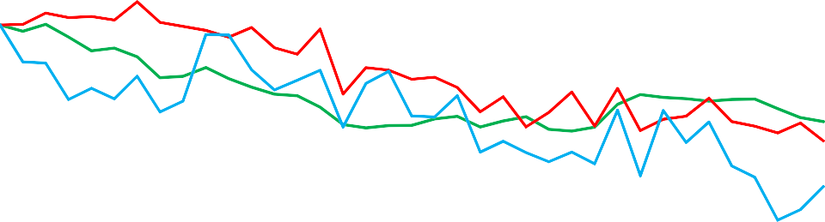

0.2

0

-0.2

-0.4

-0.6

-0.8

-1

-1.2

-1.4

-1.6

-1.8

Mar 2014

May 2014

Jul 2014

Sep 2014

Nov 2014

Jan 2015

(a) UK and euro area are CPI excluding energy, food, alcohol and tobacco. US is PCE inflation excluding energy.

Jan 2012

Mar 2012

May 2012

Jul 2012

Sep 2012

Nov 2012

Jan 2013

Mar 2013

May 2013

Jul 2013

Sep 2013

Nov 2013

Jan 2014

Core inflation rates in the euro area, the US and the UK have declined by between ¾ and 1 percentage points since 2012. Core inflation in the UK, currently around 1.4%, is likely to decline further in the coming months, reflecting sterling’s past strength and muted domestic cost growth.

The weakness in core inflation across the globe reflects the shortfall of global demand below global supply (**Chart 7**).10

# Chart 7: UK-weighted global output gap currently around -2%(a)

UK-weighted global core CPI inflation (RHS)

UK-weighted world output gap (LHS)

Per cent of world GDP

3

% yoy

2.5

2

2.3

1 2.1

1.9

0

1.7

-1

1.5

-2

1.3

-3

1.1

-4

2000

0.9

2002

2004

2006

2008

2010

2012

2014

(a) Based on Bank calculations and IMF World Economic Outlook.

In some major economies there are additional disinflationary forces. For example, in the euro area, a series of necessary internal devaluations are weighing on wages and prices. In China, a rebalancing of investment and consumption risks generating further disinflation. The producer price inflation rate has been negative for 35 months in a row, reflecting long-standing overcapacity in industries such as concrete and steel, while the more recent weakness in the property market could further increase excess capacity in related sectors.

All this suggests a persistent period of low inflation globally is a possibility, and as I mentioned a few moments ago, could itself create a self-fulfilling fear of a bad outcome. Concerns that household or government debt will weigh on demand could cause firms to delay further their already weak investment spending (**Chart 8** – see annex). Such rational corporate caution is consistent with the behaviour of many financial asset prices, which appear to be pricing the possibility of material downside tail risks, such as that economic weakness and persistently low global inflation become mutually reinforcing.11

This fear of fear itself might be reflected in other asset prices too; in particular those that measure or are influenced by inflation expectations. Along with measures from household surveys, some of these have fallen in recent months.12 Those expectations matter as they feed into the wage and price setting processes that

1. In UK-weighted terms, global output is estimated at 2% below potential.
2. Yields on sovereign bonds remain exceptionally low. In the six months to January, estimates of the equity risk premium rose by over 100bps in the UK and the euro area back to levels last seen in the heart of the crisis – December 2008 for the UK and June 2012 for the euro area. In addition, the probability of large declines in equity prices implied by options prices rebounded during 2014. Discussed in Carney, M (2015), “Fortune favours the bold”, Lecture to honour the memory of The Honourable James Michael Flaherty, P.C.,

Iveagh House, Dublin.

1. Interpreting these trends is not straightforward. Household surveys may reflect consumers’ assessments of the most frequently purchased items, for example, rather than the whole CPI basket. And financial market measures reflect not only expectations about future inflation, but also investors’ required compensation for inflation risk – the inflation risk premium – and, in the UK, the wedge between CPI and RPI inflation rates.

ultimately determine inflation. That is why central banks are keenly alert to the possibility that low inflation could de-anchor medium-term inflation expectations, increasing the persistence of inflation.

# What if inflation is slow to return to target abroad?

Protracted global weakness could heighten the challenge of returning inflation quickly to target in the UK. That’s because weak global conditions would tend to push down on the equilibrium interest rate that would maintain demand in line with supply and inflation at the target.

This equilibrium rate has likely been falling for the last three decades and turned sharply negative in the downturn.13 This meant central banks had to turn to unconventional policy tools to stimulate their economies in order to return inflation to target. In the cases of the UK and the US, these measures have been effective in supporting domestically generated inflation. Although the equilibrium rate might be turning positive in the UK as domestic headwinds have abated, it’s likely still to be negative in many countries, reflecting an excess of saving over investment, in particular in the euro area. In this regard, the ECB’s recent moves to reduce its main refinancing rate to 0.05%, its deposit facility rate to –0.2%, and to commence

large-scale asset purchases are both timely and welcome.

# Chart 9: Sterling has appreciated but trading in between US Dollar and euro since start 2014(a)

Index (Jan 2014 = 100)

120

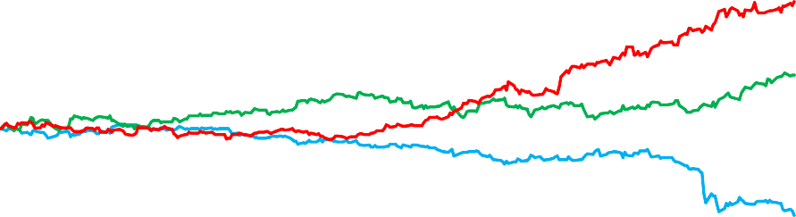

Euro Sterling

US Dollar

115

110

105

100

95

90

85

80

Jan 14

Feb 14

Mar 14

Apr 14

May 14

Jun 14

Jul 14

Aug 14

Sep 14

Oct 14

Nov 14

Dec 14

Jan 15

Feb 15

1. Computed using trade-weighted exchange rate indices for UK, US and euro area.

In an environment of low rates everywhere, even Bank Rate of ½% might look high-yielding. And the fear of a bad outcome abroad could trigger safe-haven capital flows into the UK that push the value of sterling higher, making exporting more challenging, with knock-on implications for wages and prices here.

1. That reflects an excess of saving over investment. That in turn reflects a combination of factors including the protracted process of balance sheet repair in both public and private sectors, and more secular factors like demographics (ageing and slower population growth), the higher steady state costs of financial intermediation relative to the pre-crisis period, and, possibly, lower productivity growth, as a consequence of lasting scars from the crisis. See Carney, M (2013), “The spirit of the season” at The Economic Club of New York; and box on page 42 of Bank of England (2014), Inflation Report, August.

That would come against the backdrop of a 5 ½ per cent sterling appreciation on a trade-weighted basis in the last year (**Chart 9**), which has extended the currency’s appreciation to around 17 per cent since its trough two years ago. These moves are reinforcing the disinflationary impulse from abroad, which could take a while to pass through to the sterling prices in the shops.14

# Getting back to target in the UK

All of this puts a premium on generating the domestic inflation necessary to return inflation to the target. We are on track to do that.

The UK economy is performing well. UK growth is solid, unemployment is coming down, and jobs have risen by 600,000 in the past year. Wage growth is showing signs of picking up, rising to 3% for the economy as a whole at the end of last year, and to 3.3% in the private sector.15 Average hours worked continue to recover on a strong upward trend. And firms’ labour costs grew an estimated 1.3% in the last quarter of 2014, close to core inflation.

Consumer confidence and retail sales growth are at their highest in over decade. Similarly real income growth is on course to be the strongest for more than a decade. Firms’ investment intensions are robust. Surveys point to solid growth consistent with trend. There is little evidence of a deflationary mindset setting in.

With domestic demand growing at around 3% in 2014, the fastest for ten years, all these factors will underpin the momentum needed to bring domestic cost growth back to up to a rate consistent with the inflation target.

The fall in inflation we’ve experienced is in large part down to falling energy prices. It is not generalised ‘deflation’ proper. The proportion of prices that are falling is consistent with the average over the past decade. The Bank will be vigilant in monitoring inflation expectations. Declining headline inflation seems likely to have cooled households’ inflation expectations as the prices of the goods they buy frequently – like fuel and food – have declined markedly. On balance, however, inflation expectations remain broadly consistent with the 2% inflation target. As the MPC noted in our February *Inflation Report*, we retain considerable policy options in the event that downside risks materialise.

# Conclusion

The Bank of England’s inflation target is symmetric. We care as much about inflation below target as above. With inflation below target and unemployment above its long-run sustainable rate, we are aiming to return inflation to target as quickly as possible.

1. Protracted pass-through, generated by stickiness in the domestic price of imported goods, challenges the classical view that the exchange rate provides an efficient shock-absorber in the face of foreign shocks.
2. These figures refer to the quarter-on-quarter annualised growth rate of the Average Weekly Earnings series.

In our most recent forecast, The Bank expects to return inflation to target within two years and to make limited and gradual increases in Bank Rate over the next three years in order to achieve that in a sustainable manner.

The pace and degree of these increases will be affected by a variety of factors, including the evolution of foreign prices and our exchange rate, as well as domestic cost pressures. While the MPC can be expected to look through one-off shocks, it may be appropriate to take into account persistent external deflationary forces arising from the combination of continued foreign low inflation and the protracted effects of sterling’s strength on the prices facing UK consumers if those forces were to intensify.

Cities like Sheffield have shown that in a rapidly changing global economic landscape, hard work, clarity of purpose, and fleetness of foot grant manufacturing the freedom to write its future. The MPC also faces global risks as it seeks to return inflation to target. But we remain the author of our nominal destiny. The MPC has the responsibility to return inflation to target in a timely manner and we will seek to write the next chapter that does so.

# Annex – additional charts

**Chart 5 (a): Co-movement of inflation rates(b) was relatively low under Bretton Woods…**

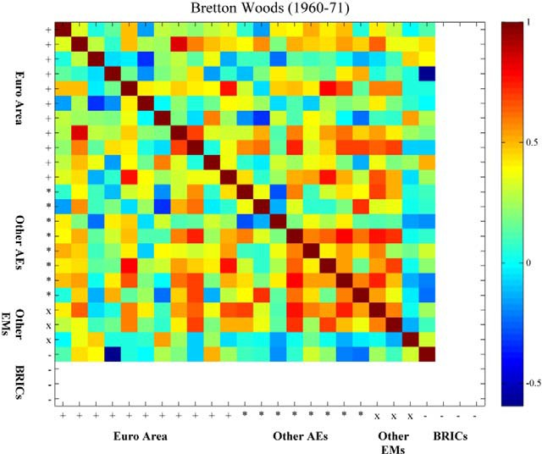

1. Uses quarterly data on annual inflation rates.

# Chart 5 (b): … and rose after the Bretton Woods system broke down…

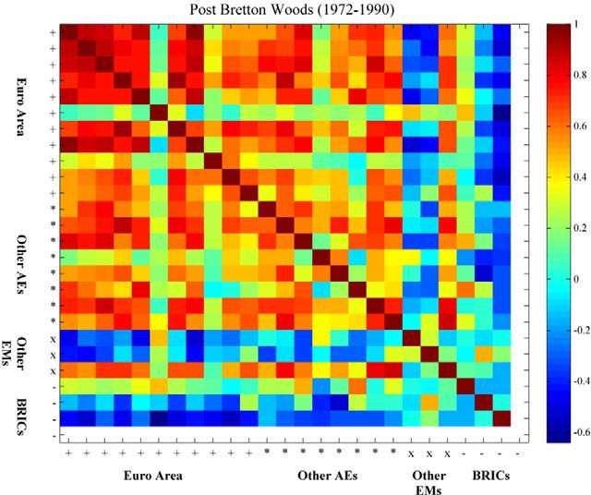

**Chart 5 (c): … cooling slightly under Inflation Targeting, though hotter than Bretton Woods…**

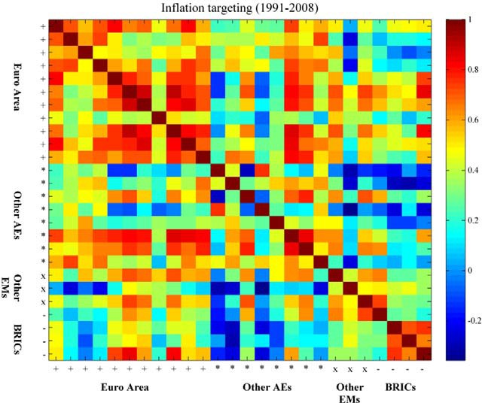

**Chart 5 (d): … and hotter still in the wake of the crisis.**

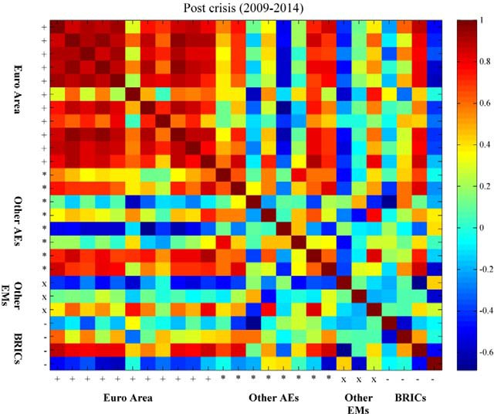

**Chart 8: Investment recoveries have been sluggish**

* 1. **UK†**

Indices, peak in GDP = 100

180

This recession

160

140

120

100

80

60

-20 -16 -12 -8 -4 0 4 8 12 16 20 24 28 32 36 40

Quarters since peak in GDP

**†** Business investment.

* 1. **Euro area†**

Indices, peak GDP=100

160

This recession

140

120

100

80

60

40

-18 -16 -14 -12 -10 -8 -6 -4 -2 0 2 4 6 8 10 12 14 16 18 20 22 24 26 28 30 32 34 36

Quarters since peak in GDP

**†** Gross fixed capital formation data from Italy, Spain, Germany and France.

**(c) United States†**

Indicies, peak in GDP = 100

180

This recession

160

140

120

100

80

60

‐20 ‐16 ‐12 ‐8 ‐4 0 4 8 12 16 20 24 28 32 36

Quarters since peak in GDP

**†** Private non-residential investment.